# PHYS1001 – PL4. Balls in Bowls

|  |  |  |  |
| --- | --- | --- | --- |
| Name: | Samuel Allpass | Lab Stream: | **PRA1-5** |
| Student Number: | S4803050 | Date: | 24/4/24 |
| Other Lab Group | Members: Emily Cooke | |  |

**Your worksheet will be given a Satisfactory/Unsatisfactory mark. To hand in your work, upload your worksheet at the Blackboard link under Learning Resources** *>* **Laboratory / Practicals.**

1. **If you are finished in class, first show your worksheet to your tutor for on-the-spot marking, then upload your worksheet (we need this for record-keeping).**
2. **If you are not finished by the end of class, you must show your work to your tutor and ask for permission to upload your worksheet after class for marking and record-keeping. If you are granted permission, you have 24 hours after the end of your class to do so.**

|  |  |
| --- | --- |
| **Today’s aim:** | Use linear regression to analyse data |
| **Overall mark:** | **Satisfactory (1)** □ **/ Unsatisfactory (0)** □ |

A satisfactory submission will generally exhibit the following criteria - if unsatisfactory, tutors will indicate which are missing:

* Communication & Presentation
  + Neat presentation and intelligible writing
  + Clear calculations
  + Clear writing, logical flow of ideas, and good grammar.
  + Coherent data presentation in tables and graphs with suitable labelling.
  + Completeness
* Scientific Method
  + Quality of data and record keeping indicates appropriate care in experimental process
  + Methods used are appropriate for the experiment
* Uncertainty
  + Uncertainties in raw data estimated and **justified**.
  + Correct use of significant figures and units.
  + Propagation of uncertainties.
* Analyse & Assess
  + Analyse the data and come to correct scientific conclusions
  + Critical evaluation of results
* Actively contributed to group (noting that participation looks different for everyone)
* Presented original work

If you receive a mark of Unsatisfactory, please email us to book a time for another attempt!

# A Estimating *g* with oscillations of balls in bowls

## A.1 Objectives

In this lab, your primary objective will be to estimate a value for the acceleration due to gravity, *g*, by measuring the period of different sized balls as they roll back and forward inside a metal dish.

The skills and concepts covered in this lab are outlined below.

Lab skills you will practice:

* Dimensional analysis - to confirm that the equations from our theory are reasonable.
* Uncertainty estimation and propagation - to inform experimental considerations for our method.
* Linear regression - a new technique that we will use to analyse our data.
* Written communication - in your discussion and conclusion.

Physics concepts you will use:

* Conservation of energy in rotational systems
* Moments of inertia
* Simple harmonic motion

## A.2 Theory

**A note on this lab’s theory section: more details of the theory contained here are covered elsewhere in the workshop and the appendix at the end. Presented here is a brief overview of the result with notes on how it can be derived.**

We begin by considering a ball that oscillates back and forth inside a bowl, as in Fig. 1. Under the right conditions, such oscillatory motion is an example of simple harmonic motion[1], with the restoring force provided by the normal force *N*. The normal force itself is a reaction force to the weight of the ball, which is directly proportional to the local gravitational acceleration. As such, it is possible to determine the local gravitational acceleration *g* by analysing data from the oscillatory motion of a ball in a bowl.

Let’s first write down an equation for the mechanical energy of this system. We note that the ball will have gravitational potential energy due to its height, translational (kinetic) energy due to the motion of the ball’s centre of mass, and rotational energy from the balls rolling motion against the bowl. This allows us to write

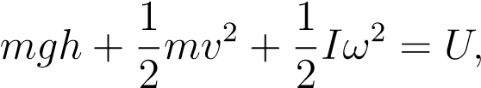 (1)

where *m* is the mass of the ball, *h* is the height of the ball’s centre of mass, *v* is the translational velocity of the ball’s centre of mass, *I* is the moment of inertia of the ball, *ω* is the angular frequency of the ball (effectively an angular velocity) and *U* is the mechanical energy of the system. If we assume that there are no losses of energy due to dissipative forces such as friction, then the mechanical energy *U* will be conserved, *i.e.* it will be constant in time.

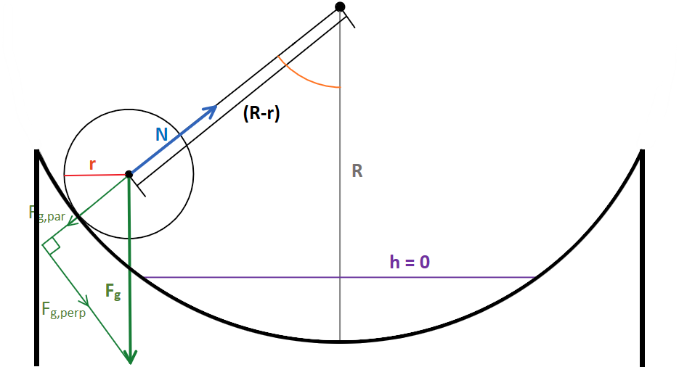

Figure 1: Geometry of a ball rolling in a bowl. Note that the *h* = 0 line is defined to be the location of the centre of mass of the ball when it is at its lowest point in the bowl. Here, *Fg* is the force due to gravity, and *N* is the normal force provided by the bowl on the ball, with *Fg,*par equalling the magnitude of *N* and *Fg,*perp providing the force accelerating the ball in the bowl. Here *R* refers to the radius of the bowl and *r* refers to the radius of the ball.

The derivation of an expression for the period of motion of the ball from equation (1) proceeds as per the following three steps:

1. Using geometry to determine an expression for *h* as a function of the angle that the ball rolls through.
2. Making a **no-slip assumption**, *i.e.* assuming that the ball does not skid or slip (but only rolls) across the surface of the bowl. Mathematically this implies the balls translational velocity is given by *v* = *rω*.
3. Noting that the moment of inertia for a solid ball is given by *Isolid*= .[2]

Finally, making use of the **assumption that the total mechanical energy** *U* **does not change in time**, and **employing the small angle approximation** (sin*x* ≈ *x* for *x* ≤ 10°) leads to the equation,

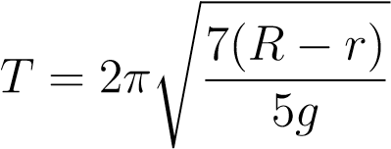*,* (2)

for the oscillation period of the ball *T*, in terms of the local acceleration due to gravity *g*, the radius of the ball *r*, and the radius of the bowl *R*.

Thus, measuring the period of the oscillations of a ball in a bowl will allow us to determine the value of the local acceleration due to gravity, *g*. We can also see that the period of oscillations should decrease with increasing ball radius, and so measuring this period with several balls of different radii should provide us with data points that can be used to perform a linear regression. As we will see soon, such a regression will also allow us to determine the radius of the bowl *R*.

## A.3 Equipment

For this lab, you will have access to the following equipment:

* 6 balls of varying radii (a small ball bearing, large ball bearing, billiard ball, small shotput, large shotput, and bowling ball).
* a 7th ball which is similar in radius to the small shotput but with a different mass.
* an 8th (hollow) ping-pong ball.
* Large dish with a large base with wooden blocks (shared with the lab).
* Small dish with a small base.
* Vernier caliper, Flexible measuring tape, Stopwatch, Ruler, and protractor.

## A.4 Workflow Summary

Your job today will be to:

* Perform a dimensional analysis on equations (1) and (2);
* Derive a relationship between *T* and *r* that can be plotted as a straight (linear) line. This equation will later be used to perform a linear regression on the data that you obtain. Such a regression will provide your experimentally determined values for *g* and *R* (with uncertainty);
* Make an estimate of *R* to compare your experimental value to;
* Write up your experimental method;
* Make measurements (including uncertainty estimates) of the period of oscillations for the first 7 balls on the equipment list (*do not* use the ping-pong ball). According to our theory, the period of these balls does not depend on mass or release location - you will be able to confirm that this is (approximately) true with the balls which have near-identical radii but different masses;
* Perform a linear regression on your data and compute values (with uncertainties) for both *g* and *R*. Compare these to previously known and estimated values;
* Perform a measurement of the oscillation period of the provided ping-pong ball. Does this measurement agree with the period predicted from equation (2)? Provide a reason why your experimentally determined value was larger than the prediction from equation (2).

|  |
| --- |
| **Box 1: Dimensional Analysis:** Confirm that the units of our equations for the mechanical energy (Equation 1) and the period of oscillations (Equation 2) are as we should expect. That is: perform a dimensional analysis on these equations and confirm that the L.H.S of equation (1) has the expected SI units for energy, and that the R.H.S of (2) has the expected SI units for time. Hint: It helps to know that the SI units for energy are kg · m2/s2.  Units of Eq. (1):  Note that I ∼ mr2 to determine units of I.  Units of Eq. (2) |

## A.5 Linear Regression

In order to analyse the data in this prac, we will be using a technique known as linear regression. The idea behind this technique is to change the variables we choose to plot so that the data we obtain lies (approximately) along a straight line given by *y* = *mx* + *c* where *m* is the gradient and *c* is the *y*-intercept of that line. Doing so makes obtaining the parameters from a line of best fit much easier, since we only have to fit a straight line rather than something curved. From equation (2) we see that plotting *T* against *r* will result in something that goes like a square root, *i.e.* not linear. So we need to choose a different set of *y* and *x* variables to plot. In this case, we can make our data look linear by choosing to plot the variables *y* = (*T*2) and *x* = *r*. We will then be able to use *m* to determine a value for *g*, and *c* to determine a value for the radius of the bowl, *R*.

|  |
| --- |
| **Box 2: Linearisation** Rewrite Equation (2) so that it takes the form (T2) = mr + c and identify what the parameters m and c correspond to. (Hint: square both sides of (2) and separate the R.H.S. into two terms.) Then rearrange your equation for *m* to obtain an equation for *g* and rearrange your equation for *c* to obtain an equation for *R*.  *m = c =*  *g = R =* |

**CHECKPOINT: Stop here and describe your linearisation to a tutor before proceeding.**

Thankfully, in this course we do not have to find the line of best fit ourselves. Instead we have the luxury of using a linear regression applet that can be found at

<https://teaching.smp.uq.edu.au/fiveminutephysics/index.html#topic=physics-Laboratories&lecture=RegressionCalculator>

This applet determines the line of best fit using the commonly employed method of least squares. This method aims to minimise the square of the distance between the actual data points and the line of best fit. If you are interested, more information can be found in the Lab Manual.

The regression applet takes as input *x*, *y*, and ∆*y*. Hence, we will need to measure/calculate *r*, *T*2, and ∆(*T*2). For further instructions on how to use the applet, refer to the Lab Manual. Feel free to ask your tutor for help if you need it. The regression applet will output not only values for *m* and *c* but also values for their associated uncertainties ∆*m* and ∆*c*. This will allow you to fully propagate your uncertainties and determine not only values for *g* and *R* but also values for ∆*g* and ∆*R*.

|  |
| --- |
| **Box 3: Uncertainty propagation** Let’s use this time to work out how our uncertainties will propagate. Use the uncertainty propagation formulas from the Lab Manual!  Determine and write down an equation for the uncertainty ∆(T2) in terms of T and ∆T:  Using your answer for g from **Box 2**, determine and write down an equation for the uncertainty ∆g in terms of only m and ∆m:  Using your answer for R from **Box 2**, determine and write down an equation for the uncertainty ∆R in terms of only c, ∆c and g, ∆g: |

|  |
| --- |
| **Box 4: Estimate of R** – Geometry We are going to estimate the radius of curvature R of a given bowl by measuring the distance across the top of the bowl (its “diameter” D) and the depth of the bowl (its “height” H). Using the sketch provided below, determine how to calculate R in terms of D and H. Hint: use Pythagoras’ theorem.  To save you some time, we note that the uncertainty in our estimate of R can be computed using: |

Figure 2: Geometry of a bowl. *R* is the bowl’s radius of curvature, *H* is the bowl’s depth or “height”, *D* is the distance across the top of the bowl or its “diameter”.

## A.6 Method

In this lab, you will be measuring the period of oscillations of balls of different radii in a metal dish. As such, you should consider how you can take measurements which minimise the rather large errors with this method. In particular, consider:

1. The average human’s reaction time to visual stimuli is approximately 200 msec.
2. Could the uncertainty due to human reaction time be minimised by allowing the balls to oscillate a number of times and then taking an average to determine a single period.
3. Although dissipative forces (mainly friction) will cause the amplitude of your balls’ oscillations to decrease with time, note that the period of the oscillations (equation 2) does not actually depend upon this amplitude.
4. Which uncertainties will contribute most to your final result (consult **Box 3**) and how can these be minimised.
5. Will taking data for all of the different sized balls be beneficial, or is it better to use only a subset of them.
6. If you have a phone, there’s nothing preventing you from using it to take measurements if you so choose.

In your method, make sure to provide a reason for choosing to do things a certain way. For example: “We then chose the same person to use the stopwatch each time to minimise the additional uncertainty arising from differing reaction times”. Also, don’t forget to **justify** your uncertainties!

|  |
| --- |
| **Box 5: Method**  The aim of this experiment was to experimentally calculate a local value for the gravitational acceleration due to the Earth. The experiment aimed at calculating g by recorded values of a balls rolling period in a dish. The following equations were evaluated:    And:    From this it was discovered that in order to calculate a value for g, we would need to know the |
|  |

**CHECKPOINT: Stop here and describe your methods to a tutor before proceeding.**

## A.7 Results

Write down your results in the spaces provided below. You may also wish to write them down in a spreadsheet program to begin with. If you didn’t do so in your method, don’t forget to **justify** your uncertainties here.

|  |
| --- |
| **Box 6: Results – Estimate of *R***  *H =*  *D =*  *R =*  *∆R =* |

**Table 1: Results for Oscillating Balls in Metal Dish**

|  |  |  |
| --- | --- | --- |
| *r* = Rall radius  (with uncertainty and units) | *T* = Period of Oscillations  (with uncertainty and units) | *T2* = Period Squared  (with uncertainty and units) |
| ± | ± | ± |
|  |  |  |
|  |  |  |
|  |  |  |
|  |  |  |
|  |  |  |
|  |  |  |

**Table 2: Result for Ping-Pong Ball**

|  |  |  |
| --- | --- | --- |
| *r* = Rall radius  (with uncertainty and units) | *T* = Period of Oscillations  (with uncertainty and units) | *T2* = Period Squared  (with uncertainty and units) |
| ± | ± | ± |

**Table 3: Experimental Results from Linear Regression**

**NOTE: DO NOT INCUDE THE PING PONG BALL IN YOUR REGRESSION**

|  |  |
| --- | --- |
| Gradient  (uncertainty/units) | *m* = ± |
| Intercept  (uncertainty/units) | *c* = ± |
| Acceleration due to gravity  (uncertainty/units) | *g* = ± |
| Radius of Bowl  (uncertainty/units) | *R* = ± |

## If possible, include a graph of your linear regression

## A.8 Discussion

In your discussion you should answer the following questions:

1. What were your experimental values for *g* and *R* (with uncertainty and units)?
2. Do the accepted and estimated values for *g* and *R* lie within the uncertainty intervals of your experimental results?
3. Which measurements contributed the most to the uncertainty of your final results? How could your method be changed to help reduce the uncertainty resulting from these measurements?
4. Were any assumptions of our theoretical model violated? If so, how would these violations have affected our results?

|  |
| --- |
| **Box 7: Discussion** |

## A.9 Conclusion

As always, your conclusion should:

1. Summarise and state the key results and outcomes of your experiment.
2. Consider how your data links to the bigger picture, *i.e.* how it compared to known results and what this implies.
3. Make a single suggestion that will be the most impactful for future experiments.

|  |
| --- |
| **Box 8: Conclusion** |

## A.10 Exploration

|  |
| --- |
| **Box 9: Consequence Questions**  Now that you have experimental values for g and R, use them in Equation 2 (along with your measured ball radius r) to make a prediction of the oscillation period of the ping-pong ball.    Does your prediction of the period from Equation 2 lie within your experimental result for the ping-pong ball from Table 2?  Provide a reason for why your experimentally determined value might be larger than the prediction from Equation 2. Hint: consider moments of inertia. |

Some other questions to consider for your own sake: Are you surprised by how complicated the theory is for what seems like quite a simple experiment? Does the physics of rotational systems seem clearer now, or is it still confusing? Do you now see how powerful tools like linear regression or dimensional analysis can be?

Taking time to reflect on questions like these will help solidify your understanding of this lab and the practical skills required. Just because the lab is finished, doesn’t mean your understanding of it is complete. A little reflection and internalisation goes a long way!

# B Appendix

**A note on this lab’s theory section: you may struggle understanding some of the concepts and theory here.** *That’s by design.* First, the physics of rotating bodies is always difficult to comprehend as it is not always intuitive where energy is stored in rotating systems or how this energy is stored. Second, a lot of physical concepts do not ’click’ until you play around with them, and the intention of this lab is to do just that. Do not worry if you do not understand any of this theory section. The important thing here is to focus on data acquisition, dimensional analysis, linearisation of physical models and error propagation. Nonetheless, it is worthwhile at least skimming this theory section. If you are confused, feel free to ask a tutor for help or even just relying on the derived equations at the end. The entire derivation is presented here as it would be patronising to assert the theory without properly justifying it, and some keen students may wish to understand the key physical concepts underlying the phenomenon under observation here.

We need to include both the translational and rotational kinetic energy terms here since the ball is not simply accelerated linearly, but rather rotates as it moves in the bowl. We will also assume that a no-slip condition holds for the ball, i.e., that the point of contact between the ball and the bowl has no horizontal motion, and so does not skid across the bowl’s surface[3] . This will help to simplify calculations greatly.

|  |  |  |
| --- | --- | --- |
| The *mgh* term – the gravitational potential energy – defines the potential difference between two points. As such, *h* can be defined to be 0 at any point, and measured as the component of the displacement normal to the surface of the Earth. Since the Earth is so large relative to the size of the bowl, we can assume the Earth is locally flat, and that *h* = 0 when the centre of mass of the ball is at its lowest point in the bowl.  As per Figures 1 and 3, we can determine the height of the ball as it rolls through the bowl through trigonometry. This is given by *h* = (*R* − *r*)(1 − cos*β*), where *R* is the radius of curvature of the bowl, *r* is the radius of the ball and *β* is the angle defined in Figure 3. Now, *β* is related to *θ*, the angle that a point on the edge of the ball rolls through, as per Figure 3. This allows us to define *β* as below: $$β=\frac{r}{R-r}θ$$ Which allows us to conclude that: $$mgh=mg×(R-r)×(1-cos\left(\frac{r}{R-r}θ\right))$$ Since we have made the no-slip assumption, this implies that the velocity of the centre of mass of the ball[4] is *rω*, and so:  . |  |  |
|  | Figure 3: Relationship between *θ* and *β*. If the ball subtends an angle *β* rolling in the bowl, then the ball itself rolls through an angle *θ*. The distance it rolls through is then *rθ*, which - due to the no-slip constraint - must equal the distance (*R* − *r*)*β*. |

Finally, the moment of inertia for a solid ball5 - which is the rotational equivalent of mass for rotating systems - is given by $I_{solid}=\frac{2}{5}mr^{2}$, and so:

$\frac{1}{2}I_{solid}ω^{2}=\frac{2}{10}mr^{2}ω^{2}$.

For a hollow ball, the moment of inertia is given by $I_{hollow}=\frac{2}{3}mr^{2}$, and so:

$\frac{1}{2}I_{hollow}ω^{2}=\frac{2}{6}mr^{2}ω^{2}$.

We will focus on the solid ball for the rest of this derivation, but the same process applies to hollow balls. Putting everything together, we can see that:

$mg×\left(R-r\right)×\left(1-cos\left(\frac{r}{R-r}θ\right)\right)+\frac{1}{2}mr^{2}ω^{2}+\frac{2}{10}mr^{2}ω^{2}=U$.

Simplifying, we can obtain:

$\frac{mgr}{2}×\left(R-r\right)×\left(\frac{r}{R-r}θ\right)\left(1-cos\right)+\frac{7}{10}mr^{2}ω^{2}=U$.

The pesky constant on the right-hand side of the equation poses some difficulties for our purposes. We could measure or compute the mechanical energy, but it is simpler to derive both sides of the above equation with respect to time, t, since we know that U is a constant with time. We will also note that, by definition, and hence , i.e., the angular acceleration. Deriving with respect to time, we obtain:

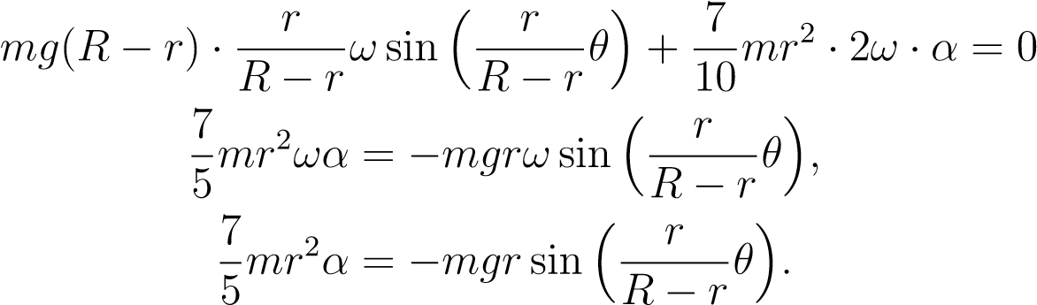*,*

If the maths is somewhat overwhelming, do not worry – again, the purpose of the lab is not necessarily to obtain a complete physical understanding but rather to provide a lab which will assess your experimental skills. Next, we can make what’s deemed the small angle approximation. For sufficiently small values of *x* (in radians), it is approximately true that:

sin*x* ≈ *x.*

For *x < π/*18 (i.e., *x <* 10°), the error in sin*x* ≤ 0*.*5%, and so this tends to be a good approximation below angles of 10°. Recall that , and so provided *β <* 10°(which we can ensure by rolling our ball across only a small arc of the bowl), we can simplify the above expression as:

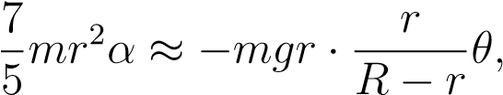

which allows us to write:

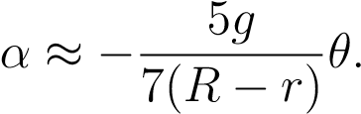

1. <http://hyperphysics.phy-astr.gsu.edu/hbase/shm.html>
2. In contrast to the moment of inertia for a hollow ball, which is given by *Isolid*=
3. <https://physics.info/rolling/>
4. <https://physics.info/rolling/>